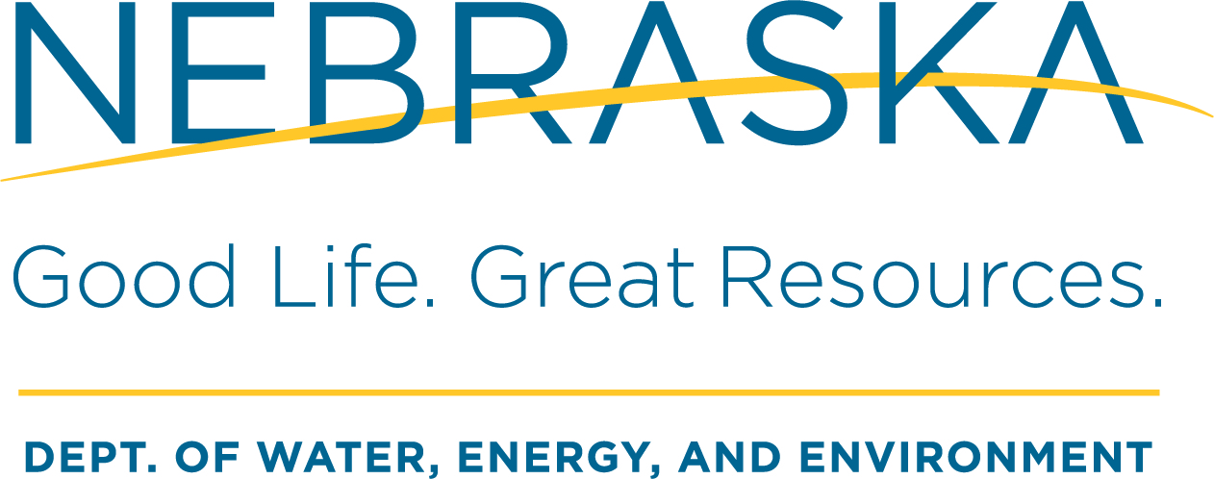

Water Well Standards
245 Fallbrook Blvd., Ste 100
Lincoln NE 68521
Phone: 402-471-0546 | FAX: 402-471-6436

COMPLETION OF CONTINUING EDUCATION PROGRAMS

Please Type or Print Clearly

[Name] :

1. That above named is the person completing this form.

2. That above named lives at [Street, PO Box], [City], [State], [ZIP], [Telephone Number].

3. That the above named holds a license issued by the Department of Water, Energy, and Environment, under the Nebraska Water Well Standards and Contractors’ Licensing Act, Number .

4. That for the period between [Month/Date/Year] and [Month/Date/Year], he/she has completed the continuing education courses named below on the dates and at the locations described and for the number of hours set forth below:

PROGRAM NAME/PROVIDER | PROGRAM LOCATION | PROGRAM DATES | HOURS EARNED

- That copies of all certificates or other evidence of completion provided by the program sponsor for each program listed in paragraph 4 are hereby attached. Proctors name must also be provided when submitting webinar requests. (Enclose copies of all such documents with the filing of this affidavit.)

Signature: _________________________________________ Date:_______________

