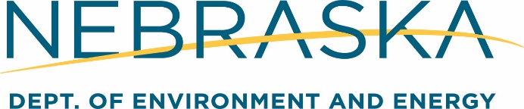

*This guidance document is advisory in nature but is binding on an agency until amended by such agency. A guidance document does not include internal procedural documents that only affect the internal operations of the agency and does not impose additional requirements or penalties on regulated parties or include confidential information or rules and regulations made in accordance with the Administrative Procedure Act. If you believe that this guidance document imposes additional requirements or penalties on regulated parties, you may request a review of the document.*

00-069 August 1, 2024

**Summary of Title 200**

The Title 200 Program

The Petroleum Release Remedial Action Cash Fund (Fund) is managed by the NDEE’s Petroleum Remediation Section (PRS). The Fund assists tank owner/operators with costs to investigate and cleanup petroleum releases. Releases reported after July 17, 1983, and on or before June 30, 2028 are covered.

Title 200 Application Phases

Applications are sent after approved remedial phases are completed, such as:

* Closure Assessment Report (limited).
* Site Investigation (i.e., Tier 1, or Tier 2 Report).
* Remedial Action Plan.
* Remedial System Installation.
* Monitoring Reports.
* Well abandonment, equipment removal, and other site closure activities; or
* Other approved activities.

An application must be submitted within **one year** of the compliance date or the date the report is received. Reimbursement may be reduced up to 100% if the application does not meet this deadline. This applies only after costs exceed the initial deductible.

Deductible and Co-payment Requirements

The first application is sent after costs exceed the deductible amount. RPs then apply for 75% of eligible costs until their co-payment is met. After both are met, RPs apply for 100% of eligible costs until the release is closed or the limit is reached.

Most RPs pay a $10,000 per release deductible with a 25% co-payment of up to $15,000. After the RP has met the $25,000 deductible and co-payment obligation, 100% reimbursement of all eligible expenses is made up to $975,000.

Some RPs qualify for a lower deductible and co-payment if they are either:

* A marketer who sold more than 2,000 but less than 250,000 gallons of petroleum at all facilities in the calendar year prior to the year the release was first reported.
* An RP who stores petroleum for personal or business use, who stored less than 10,000 gallons at all facilities in the calendar year prior to the year the release was first reported.

An RP classified as low volume has a $5,000 deductible with a 25% co-payment of up to $10,000. After the RP has met the $15,000 deductible and co-payment obligation, 100% reimbursement of all eligible expenses is made up to $985,000. To be classified as low-volume, an “Application for Low-Volume Classification” is needed.

General Eligibility Issues

Statute directs Title 200 staff to reimburse actual, reasonable, and eligible costs for NDEE-approved remedial actions. To do this each application review compares the invoices to the information in the technical report(s). More information is found in the Reasonable Rate Schedule and Reimbursement Guidance Manual.

Factors That May Reduce Reimbursements

Reimbursements to RPs may be reduced up to 100% for failure to comply with the rules and regulations of the State Fire Marshal, the NDEE and other agencies, pursuant to Neb. Rev. Stat. §66-1525. Reimbursements may also be reduced for the failure to submit the report by the compliance date or apply for reimbursement within one year of the report date. More detailed information is found in the Reimbursement Reduction Guidance document.

*Nebraska Department of Environment and Energy, Petroleum Remediation Section, P.O. Box 98922, Lincoln, NE 68509-8922; phone (402) 471-2186. To view this, and other information related to our agency, visit our web site at* [*https://dee.nebraska.gov*](https://dee.nebraska.gov)