**FACT SHEET**

**No Further Action Decision**

**BNSF Scottsbluff Release #110500-NH-0100, IIS #72956, Scottsbluff, NE**

The Nebraska Department of Environment and Energy (NDEE) is providing public notice of its intent to require no further action at the Burlington Northern and Santa Fe Railway Company (BNSF) Scottsbluff derailment site, spill #110500-NH-0100, located on the western side of Scottsbluff. This fact sheet provides background information on the site, a summary of contamination, a description of the remedial action, a description of the public participation procedures, and the NDEE contact person.

**Site Location:** The derailment spill site is located NE ¼ of the NE ¼ of Section 22, Township 22 North, Range 55 West, in Scotts Bluff County Nebraska.

**Nature and Extent of Contamination:** On November 4th, 2000, a train derailment occurred causing the release of approximately 85,000 gallons of liquid Aromatic Concentrate Grade 1 containing Volatile Organic Compounds (VOCs) Dicyclopentadiene ~10%-20% (DCPD), Benzene ~40%-50%, Toluene ~3%-8%, Ethylbenzene ~0.5%-1%, Xylenes ~0.1%-1% (BTEX), Styrene ~1%-6%, Naphthalene ~0.1%-1%, and other chemicals ~4.5%-18%, at the BNSF railroad tracks located near W. 25th St. and Ave. L in Scottsbluff, Nebraska. BNSF was responsible for the release. Soil and groundwater contamination resulted from the spill.

**Soil Contamination:** Soil contamination occurred and was noted as migrating to the subsurface shortly after the spill. Due to the shallow depth to water, the liquid nature of the contaminants, and the soils consisting of sand, the soil did not prohibit the contaminants from reaching the groundwater.

**Groundwater Contamination:** Groundwater beneath the release was impacted due to the shallow depth to water and composition of the overlying alluvial sediments. The extent of which was determined by monitoring wells that were placed around the site. The direction of regional groundwater flow in the area is generally southeast.

**Groundwater Use in the Area:** The site is located within the Scottsbluff Wellhead Protection Area with the nearest municipal well greater than 2500 feet away from the remaining plume of DCPD. There is one downgradient registered domestic well to the east southeast of the spill site approximately 1000 feet. There are two registered domestic wells that are cross gradient approximately 2000 feet to the southwest of the spill site. There are other registered wells labeled as industrial wells upgradient to the north of the spill site approximately 500 feet.

**Groundwater Remedial Action Class:** The NDEE assigns a Remedial Action Classification (RAC) to a groundwater contamination event to determine the importance of remedial action, in part, on the use of groundwater in the area (Nebraska Title 118, Appendix A, Step 8). Groundwater that is being used as a public drinking water supply is assigned the highest remedial action class of RAC-1. Groundwater that has the potential of being used as drinking water is generally designated as RAC-2. The Department typically requires extensive cleanup of groundwater that is classified as RAC-1 or RAC-2. When the use of groundwater in the area is more limited, the groundwater is assigned a RAC-3 (lowest priority). Generally, groundwater cleanup will be less extensive for this classification. The pollution event for this site has been classified as a RAC-1.

**Remedial Actions:** On December 1st, 2000, an emergency permit was approved by the Department to allow BNSF to remove and store contaminated soils which were eventually treated and moved to a waste facility. A pilot study of injecting an oxidizer, peroxydisulfate, into the groundwater to oxidize the DCPD and reduce its plume in the groundwater was employed in May of 2002. This pilot study was used to gauge the efficacy and efficiency of this method. A remedial action plan was produced in March of 2003 and implemented in October of 2003 to provide alternatives for continued remediation of the site. Multiple remedial methods were utilized and have significantly reduced contamination on the site. An Alternative Cleanup Level (ACL) for contamination of groundwater was set for the DCPD at 1.67 mg/L, Benzene at 0.076mg/L, Ethylbenzene at 2.75mg/L, Toluene at 5.49mg/L and Xylenes at 26.1mg/L. These levels were achieved across most of the site with active remediation methods such as Air Sparging (AS), Soil Vapor Extraction (SVE), Groundwater Removal and Treatment, Ozonation, Fenton’s Reagent Injections, and Permanganate Injections. There is a remaining portion of the site that still has DCPD levels above the ACL located under the railroad tracks in between KIW-03 and KIW-04. The DCPD levels around KIW-03 have remained stable, but KIW-04 has shown a slight increase in the last few years. The closure report for the site concludes that natural aerobic processes will sufficiently deplete the limited remaining DCPD at the site and achieve the ACL in the future.

Benzene was last detected at the site above the ACL in 2010 in KIW-03. Toluene, Ethylbenzene, and Xylene have not been detected above the ACL at the site since 2005.

Since 2007, the site pivoted from active remediation efforts to passive remediation. The passive remediation consists of letting natural aerobic processes biodegrade the DCPD as oxygen is naturally absorbed into the soils around the small area that is still contaminated by the DCPD. This process is called Monitored Natural Attenuation (MNA) and has been the primary passive remedial mode since 2007. The downgradient wells from the spill have indicated the MNA of DCPD has brought the contaminant level below the ACL.

As of 2023, the Mann-Kendall analysis of KIW-03 shows a stable trend of DCPD with the most recent data point showing a concentration of 3.7 mg/L. The Mann-Kendall analysis of KIW-04 shows an increasing trend of DCPD with the most recent data point showing 5.9 mg/L. KIW-04 has dropped below the ACL previously multiple times. The DCPD is likely bound in the soil below the railway tracks just above the water table making it difficult to physically remove. The time required to achieve the DCPD ACL at KIW-03 and KIW-04 via natural attenuation is uncertain. However, plume analysis indicates the plume is stable and not expected to migrate beyond its current footprint where no exposure pathways are present.

To understand the behavior of the remaining DCPD underneath the tracks, graphs comparing the groundwater elevation to the DCPD concentration were produced. The graphs indicate that as groundwater elevation increases, DCPD levels increase. As groundwater elevation decreases, DCPD levels decrease as air is replacing groundwater in between soil particles, resulting in the natural aerobic processes continuing to degrade the DCPD. This indicates a correlation between groundwater levels and DCPD levels. These graphs are pictured below.

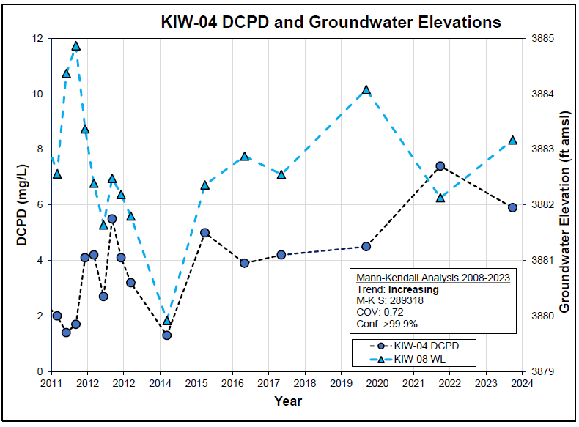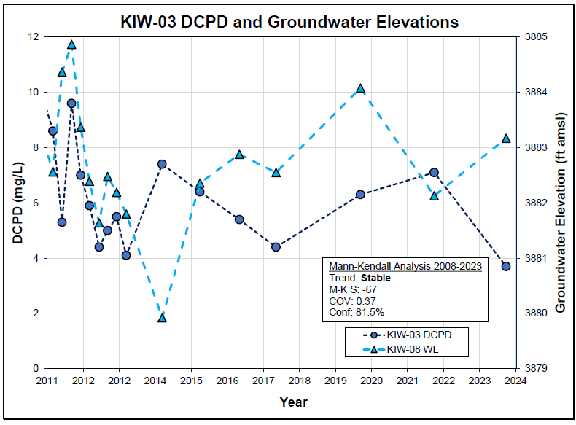

Although these two wells are currently above the ACL for DCPD, the trend analysis of surrounding wells show that the plume is stable and a majority of the DCPD mass has been oxidized by natural aerobic processes and the remainder will continue to naturally degrade.

**Project Milestones:**

* November 4, 2000: Train Derailment near Scottsbluff, Nebraska.
* October 27, 2003: NDEQ issues alternate cleanup levels for Site groundwater.
* 2004: All groundwater levels in remedial zones 2, 3, 4, and 5 were below ACLs, rebound monitoring was completed, and all monitoring and remediation wells in these zones were abandoned.
* 2005: All groundwater levels in remedial zone 1B were below ACLs, rebound monitoring was completed, and all monitoring and remediation wells in these zones were abandoned.
* 2006: Shutdown of AS/SVE, thermox treatment unit, and groundwater pumping systems.
* 2009: The remaining Remediation Zone 1A was reduced in size to the source area and the immediate down gradient area, monitoring was reduced to 14 wells on a quarterly basis.
* 2011: Site decommissioning. Removal of remedial systems outside of the source area. AS/SVE, monitoring wells, and recovery wells inside of the source area remain.
* 2013: Groundwater monitoring was reduced to 13 wells on an annual basis.
* 2015, 2016, 2017: Annual monitoring of 13 wells until ACLs were achieved. Agency approved reduction of sampling frequency to every other year in 2017.
* 2019: Continued biennial groundwater monitoring. Two monitoring wells remain above ACLs for DCPD.
* 2021: Existing Site monitoring and SVE wells abandoned in accordance with State regulations, with the exception of six monitoring wells. Biennial groundwater sampling completed in September 2021.

**Environmental Covenant:** An environmental covenant will be put in place by BNSF for the property owned by BNSF that encompasses the site. The purpose of the covenant is to ensure protection of human health and the environment by minimizing the potential for exposure to contaminants that remains at the property and to ensure that the property is not developed, used, or operated in a manner incompatible with the terms of site closure. As of 2/28/2025 the environmental covenant is still in production, though a draft covenant is provided in the Closure Report, document #20240210318.

**Proposed Actions:** The Department is requiring no further action at the release location based on the following:

* All monitoring wells are below the ACL for BTEX.
* The contaminant plume of DCPD is well defined and confined to a small area with little to no risk of movement from its current location as no exposure pathways are present.
* Most monitoring wells have shown decreasing and stable contaminant levels through MNA, indicating a lack of plume growth.
* Drinking water wells are not at risk of being impacted by contamination.
* An environmental covenant is being prepared to prevent drinking water well installation or disturbance of the remaining plume around the release.

**Public Participation Procedures:** You may receive additional information, submit written comments regarding the proposed actions, or request a hearing, in writing, on or before April 23rd, 2025, if you request a hearing, you must state the nature of the issues to be raised, present your arguments, and facts to support your position in writing to the Department. If the Director grants a public hearing, the hearing will be advertised by public notice at least 30 days prior to its occurrence. Comments and requests should be mailed to Laura Johnson, Drinking Water and Groundwater Division, Nebraska Department of Environment and Energy, PO Box 98922, Lincoln, NE 68509-8922, phone (402) 471-2186.

**Contact:** Fileinformation for this VOC release is available for inspection at the office of the Nebraska Department of Environment and Energy in Lincoln, NE. These materials may also be viewed online at <http://dee.nebraska.gov> by selecting “Public Hearings/Notices” at the bottom of the page. Please notify the Department of Environment and Energy if alternate formats of materials are needed by April 23rd, 2025. Further information may also be obtained from Caelum Hubl, Groundwater Section, contact the office at (402) 471-2186. TDD users please call 711 and ask the relay operator to call the office at (402) 471-2186.